Scholarship Helper User Manual

An application by Mweya Ruider, Helena Paulo, Lonata Penondyo, Anthens Liyali

# Introduction

The Scholarship Helper application is an application written to help manage applicants for a scholarship, making it easier on the staff overseeing this process.

# Installation

The installation process is as follows:

1. Install Python3
   1. Any build of Python3 should work however the ActiveState version was used during development and should therefore result in a more stable experience
2. Install Microsoft SQL Server
   1. The SQL Express server variant was used during development and is recommended
3. Install the Python dependencies
   1. A textfile with dependencies should be in the same directory to make this easier
4. Launch by running ScholarshipHelper.py

# Use

## Viewing Applicants

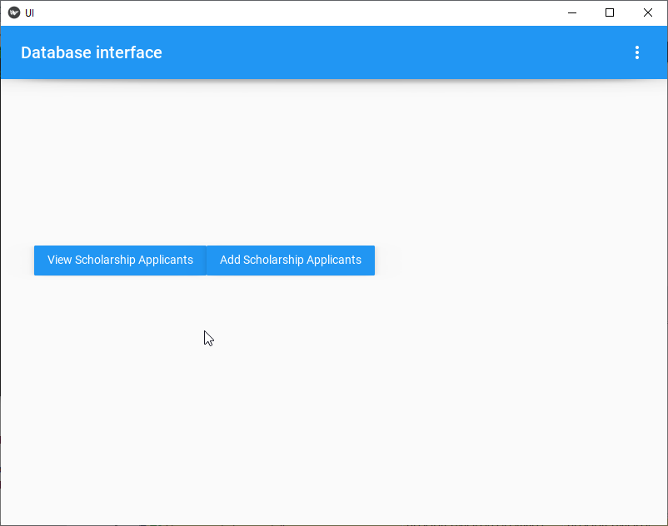

To view applicants, click on the “View Scholarship Applicants” view above. This should take you to the following screen where a part of a name can be entered to search for a specific applicant.

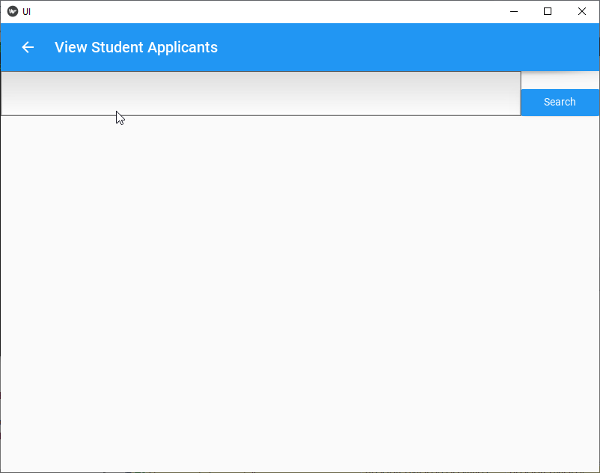

The bar above can be used to enter part of a name and the search button can be used to actually search the database for users with matching information, as shown below:

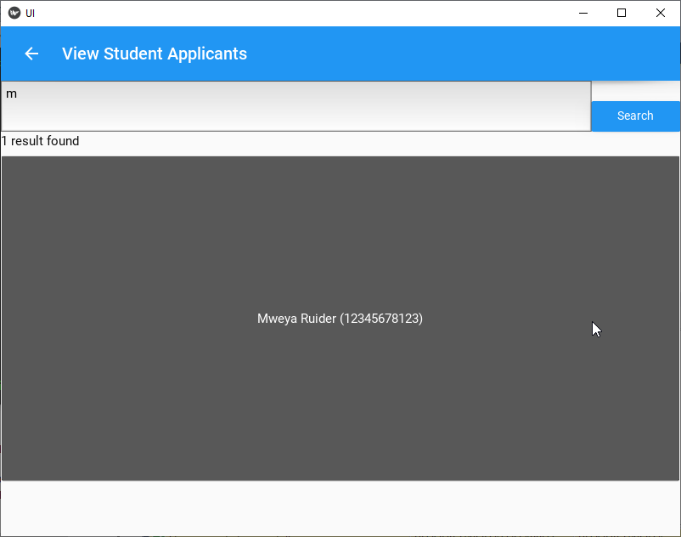

This example shows that there is one applicant who has a name with an “M” in it. Clicking on this result takes you to the applicant information screen as shown below while clicking on the search button above will re-run the search.

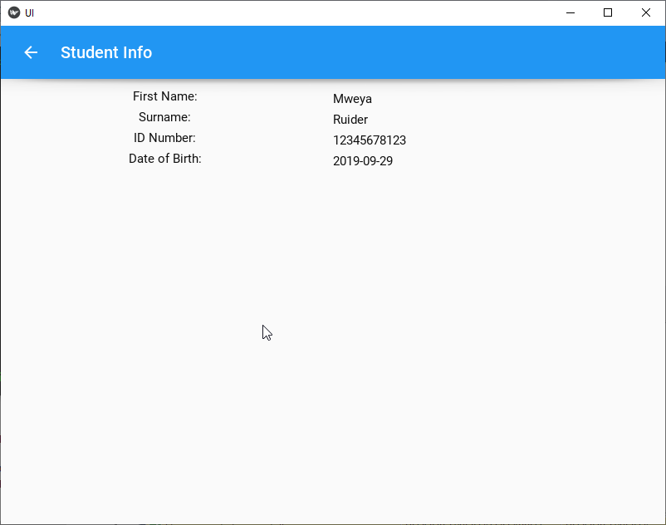

This shows the applicant information screen where critical information on this applicant can be seen. Later iterations of this prototype aim to have options here to edit the information shown here as well as store relevant documents and delete all information on this applicant’s profile.

## Adding Applicants

The process of adding applicants can be started by clicking the “Add Scholarship Applicants” button shown above, which will take you to an information entry screen like the one shown below.

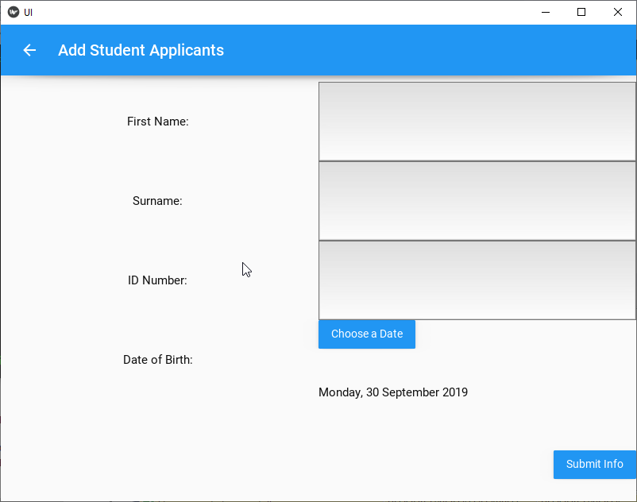

Relevant information like the name, surname, ID number and date of birth can be added above with the input methods shown. The Submit Info button inserts the information given above into the database for later use.